Software Project Management Plan (SPMP) for Enkripsi dan Dekripsi Chat Client Server Project

*9 Agustus 2015*

Issued by : Merdiana Puspita

Issued for : Robertus Hudi

**Preface**

Dokumen ini bertujuan untuk memenuhi kebutuhan dari tugas laboratorium Rekayasa Piranti Lunak dan projek kelompok dari mata kuliah keamanan komputasi. Oleh karena itu untuk menyelesaikan proyek enkripsi dan dekripsi chat client server secara tepat waktu dan memenuhi kebutuhan dari program tersebut dokumentasi ini dibuat. Dokumen ini juga bertujuan agar rekan satu team kami dan dosen yang mengajar dapat mengetahui perkembangan projek kami.

***Important Notes for Soft-copy Viewing***

Tipe dari dokumen ini adalah Microsoft word 2007.

**Chapter 1**

**INRODUCTION**

* 1. **Project Overview**

Membuat chat client server yang aman dari serangan keamanan jaringan

* + 1. **Purpose, Scope, and Objectives**

Tujuan dari project ini adalah untuk menganalisa kebutuhan, design, implementasi yang dibutuhkan oleh chat client sever agar aman dari serangan keamanan jaringan.

Tujuan dari project ini seperti yang disebutkan dibawah :

* Menyelesaikan project sebelum hari pengumpulan tugas
* Menyelesaikan project delam budget yang sudah ditentukan
* Memenuhi kebutuhan (permintaan) yang sudah disebutkan pada SRS
* Memenuhi requirement yang terdapat dalam SRS
  + 1. **Assumptions and Constraints**

Berikut adalah daftar dari asumsi-asumsi dalam project ini:

* This project will deliver only the software components of the larger project
* The hardware is not included in this project, and is handled as a different project. Hardware is assumed to be ready at least by the end of this project.

Here is the list of all constraints that are made :

* Budget
  + $0
* Time
  + 3 minggu sejak pemberian tugas di mata kulian keamanan komputasi
  1. **Project Deliverables**

Berikut adalah daftar item yang akan tercakup kedalam project ketika selesai :

* Software program, bersamaan dengan library yang menyertainya
* Software documentasi
* Project documentasi :
  + Software Project Management Plan (SPMP)
  + Software Requirement Specification (SRS)
  + Software Design Description (SDD)
  + Software Test Documentation (STD)

**Chapter 2**

**PROJECT ORGANIZATION**

1. **Software Process Model**

*Use this part to state what software process model that you choose. Mention any consideration that you put in choosing it. Remember, whatever software process model you choose here should affect the whole project’s run.*

1. **External Intefaces**

*Use this part to mention all project participants who aren’t necessarily in your team (hence external) and yet take parts in larger scale of your project. In order to make it clearer, you can provide this information using a chart. Following is an example of the chart.*

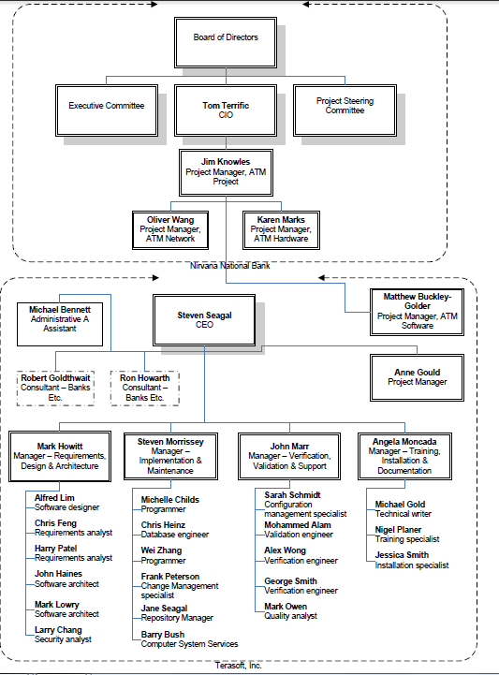

1. **Internal Structure**

*Use this part to mention who are involved in your team as project participants. Following is an example of a chart that gives that information.*

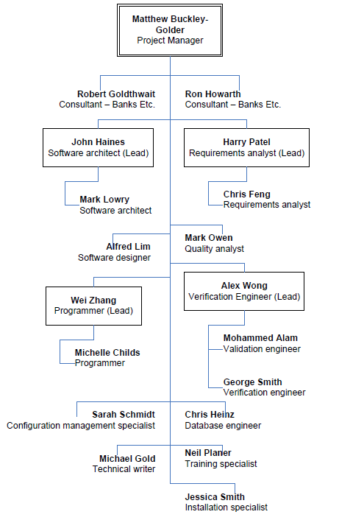

1. **Roles and Responsibilities**

*In general, this part gives information about who will be responsible in doing tasks or deliverables that are needed. As a suggestion, you can use Responsibility Assignment Matrix (RAM). Definition about RAM can be found online or on literature. Following is an example of how RAM looks like. As a side note, you are required to have at least 25 WBS (main WBS), therefore you should at least have 25 ID’s in this table. Every individual that is mentioned in your internal structure (2.3.) must be included in this table as well.*

|  |  |  |  |  |  |  |  |  |
| --- | --- | --- | --- | --- | --- | --- | --- | --- |
| ID | WBS | Deliverables | CEO | Project Manager | Requirement Analyst 1 (Lead) | Requirement Analyst 2 | Programmer 1 (Lead) | … |
|  | 1 | Blabla Project |  |  |  |  |  |  |
|  | 1.1 | Software Lifecycle Model Process |  |  |  |  |  |  |
| 1 | 1.1.1 | Select project model |  | L |  |  |  | … |
| … | … | … | … | … | … | … | … | … |
|  | 1.2.4 | Plan Project Management |  |  |  |  |  |  |
| 13 | 1.2.4.1 | Create baseline WBS |  | L | C |  | C | … |
| … | … | … | … | … | … | … | … | … |
|  | **Key** |  |  |  |  |  |  |  |
|  | A | Approval | 21 | 10 | … | … | … | … |
|  | L | Lead | 4 | 2 | … | … | … | … |
|  | S | Secondary | 0 | 4 | … | … | … | … |
|  | C | Contributor | 0 | … | … | … | … | … |
|  | R | Reviewer | 2 | … | … | … | … | … |

1. **Tools and Techniques**

*Use this part to list all tools and techniques that you will use in this project.*

**Chapter 3**

**PROJECT MANAGEMENT PLAN**

1. **Work Activities**

*In this part, you are required to list all your WBS. Remember, you need to have at least 25 main items, which means your ID here can go (or even, should) more than 25. Following is an example of how your WBS list should look like.*

|  |  |  |  |  |  |
| --- | --- | --- | --- | --- | --- |
| **ID** | **WBS** | **Task Name** | **Duration** | **Predecessors** | **Successors** |
| 1 | 1 | Blabla Project | 250 days |  |  |
| 2 | 1.1 | Software Lifecycle Model Process | 2 days |  |  |
| 3 | 1.1.1 | Select project model | 1 day | 2 |  |
| … | … | … | … | … | … |
| … | … | … | … | … | … |
| 200 | 1.15 | Maintenance | 1 day | 180 | 201 |
| 201 | 1.15.1 | Reapply a software lifecycle | 5 days | 198 |  |

1. **Activity Network**

*Using dependencies that you have from Work Activities above, you are required to make an activity network here. Example of how activity network looks like can be found at TM.*